ASSIGNMENT-2

Flask

|  |  |
| --- | --- |
| Assignment Date | 19 September 2022 |
| Student Name | Aiswaryaroy S |
| Roll Number | 510419104004 |

1) Create user table with user with email, username, roll

number and password

-- Creating user table in sqlite3

Create table EMP(

Email varchar(51),

Username varchar(51),

Roll number int,

Password varchar(21)

)

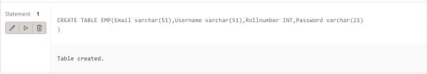

2)Perform UPDATE, DELETE Queries with user table

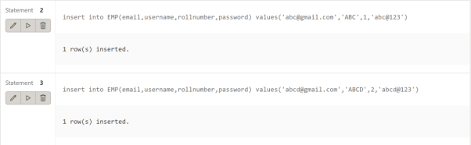

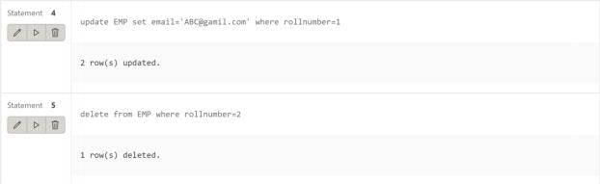

3) Create a flask app with registration page, login page and

welcome page . By default load the registration page once the user enters all the fields store the data in database and navigate to login page authenticate user username and password . If the user

is valid show the welcome page

Sign up page:



SIGNUP PAGE HTML CODE

<!DOCTYPE html>

<html lang="en">

<head>

<meta charset="UTF-8">

<meta name="viewport" content="width=device-width, initial-scale=1.0"> <title style="font-family: sans-serif">Sign up</title>

</head>

<style>

h1{

text-align: center;

font-size: 10ch;

color: white;

}

body{

background-color: #659DBD;

text-align: center;

}

body{

background-image: url("im.gif");

background-position: center;

background-repeat: no-repeat;

background-size: cover;

}

p{

color: white;

font-size: x-large;

font-family:'Times New Roman', Times, serif;

}

small{

color:rgba(168, 61, 61, 0.71);

font-size:3ch;

}

input[type=submit] {

background-color: rgba(0, 0, 0, 0);

font-family: 'Times New Roman', Times, serif;

border: none;

color: white;

padding: 15px 10px;

text-decoration: none;

margin: 2px 2px;

cursor: pointer;

}

</style>

<body>

<h1><u>SIGNUP</u></h1>

<form method="POST" action="">

<p>USERNAME</p>

<input type="text" name="username" id="username" maxlength="25" size="25" required>

<p>EMAIL</p>

<input type="text" name="email" id="email" maxlength="25" size="25" required>

<p>ROLL NUMBER</p>

<input type="text" name="rno" id="rno" maxlength="25" size="25" required>

<p>PASSWORD</p>

<input type="password" name="password" id="password" maxlength="25" size="25" required>

<br><br>

<input type="submit" value="SIGNUP">

<br><br>

<small><u>ALREADY HAVE AN ACCOUNT<a href="{{ url for('login') }}"><br></u>

<small><u>LOGIN</u></small>

</form>

</body>

</html>

SIGNUP FUCTION IN FLASK

@app.route("/",methods=["GET","POST"])

def signup():

if (request.method=="POST"):

rno = request.form.get("rno",'')

email = request.form.get("email")

username = request.form.get("username",'')

password = request.form.get("password",'')

with sqlite3.connect("users.db") as con:

cur = con.cursor()

cur.execute("INSERT INTO user (roll number,email,username,password) VALUES (?,?,?,?)",(rno,email,username,password) )

con.commit()

return redirect(url for('login'))

return render template("signup.html")

Login Page :

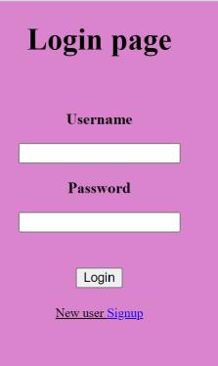

LOGIN PAGE HTML CODE

<!DOCTYPE html>

<html lang="en">

<head>

<meta charset="UTF-8">

<title>Login</title>

<link href="style.css">

</head>

<style>

body{

text-align:justify;

background-color: #41B3A3;

}

</style>

<body>

<h1>LOGIN PAGE</h1> <br>

<form method="POST" action="">

<p><b>USERNAME</b></p>

<input type="text" name="username" id = "username"> <br>

<p><b>PASSWORD</b></p>

<input type="password" name="password" id="password"> <br> <br><br>

<input type="submit" value="LOGIN">

<p><small><u>New User?</u><a href="{{ url for('signup')

}}">Signup</a></small></p>

</form>

</body>

</html>

LOGIN FUNCTION IN FLASK

@app.route("/login",methods=["GET","POST"])

def login():

if request.method=="POST":

username = request.form.get("username",'')

password = request.form.get("password",'')

with sqlite3.connect("users.db") as con:

cur = con.cursor()

cur.execute("select * from user where username=(?) and

password=(?)",(username,password))

result = cur.fetchone()

con.commit()

if result==None:

return render template("login.html",msg="Invalid Username and

password")

else:

return render template("home.html",username=result[1]) return render template("login.html")

Home Page:

HOME PAGE HTML CODE

<!DOCTYPE html>

<html lang="en">

<head>

<meta charset="UTF-8">

<title>Home page</title>

</head>

<body style="background-color: #4bb574">

<p>WELCOME TO THE HOME PAGE</p>

</body>

<style>

p{

text-align: center;

font-family: serif;

font-size:1cm;

}

</style>

</html>